OSG Technical School

Vol.1. Basic information

Vol.1. Basic information

Contents

Ⅰ. What is thread

1. Threads are everywhere……………………………...……… 1
2. The theory of thread………..….……………………...……... 2
3. Types of thread….………………………..….………………. 3
1) Screw thread………………………………….…………………….. 4
2) Unified thread………………………………………………….…… 5
3) Whitworth thread………………………………………………….... 7
4. Description of threads……………..……………….…..…….. 8
5. The name of thread’s detail……...…………………….……… 9

Ⅱ. Gauge

1. Usage of Gauge………………………….…………..………. 11
2. Limit of thread………………………………..……..………. 11
3. Types of gauge………………………………….….……… 11
4. Description of Gauge………………………...……………… 13

Ⅲ. Basic of Tap

1. What is tap?…………………………………….…………... 14
2. Feature of Tap……………………………………………… 14
3. Terminology………………………………………………... 14
4. Tapping Mechanism………………………………………… 15
(1). Chamfer………………………………………………………….. 15
(2). Flute……………………………………………………………… 15
(3). Rake angle……………………………………………………….. 17
(4). Shank…………………………………………………………….. 18
(5). Shank square……………………………………………………... 18
(6). Center…………………………………………………………….. 18

Ⅳ. Material / Limit / Surface treatment

1.The material of tap………………………………………….. 19
(1). High Speed Steel (HSS)……………………………………….. 19
(2). Powder Metallurgy HSS (CPM, XPM)…………………………. 20
(3). Carbide…………………………………………………………... 20
(4). Alloy Steel Tool (SKS)………………………………………….. 21

2. Limit of Tap………………………………………………... 21
(1). Limit of Internal thread………………………………………….. 21
(2). Limit of Tap……………………………………………………… 22

3. Surface treatment of Tap……………………………………. 27
(1) Steam Oxide……………………………………………………… 27
(2) Nitride……………………………………………………………. 28
(3) TiN coating………………………………………………………. 29
(4) TiCN coating……………………………………………………... 30
(5) Summary of surface treatment…………………………………… 30

Ⅴ. Types of Taps

1. Standard taps, special taps, and taps per applications………. 32
2. Flute of the taps……………………………………………... 32
3. Materials…………………………………………………….. 36
4. Other categories……………………………………………... 36

Ⅰ. What is thread

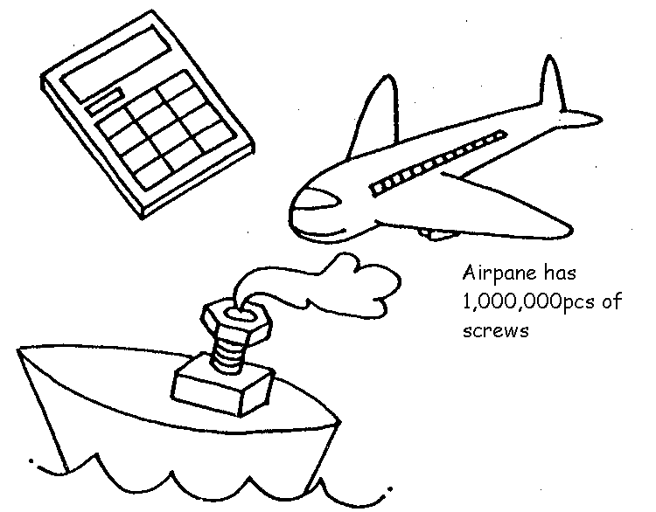
1. Threads are everywhere

There are a variety of threads from small products such as a calculator, glasses to big ones like an airplane, a ship. A car generally has about 3000pcs of threads. Threads play an important role in our lives.

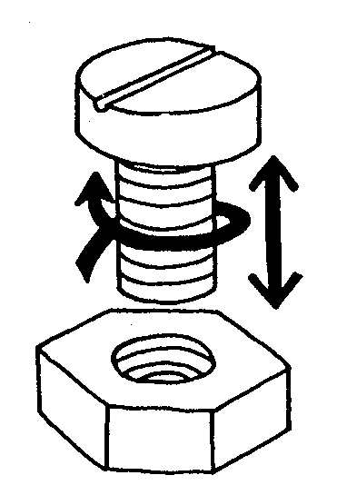

2. The theory of thread

Generally Thread can be categorized in external thread and internal thread. The external thread go into the internal thread by rotation. In other words, rotary motion turns into linear motion which convert small power to big power. This is used for many applications as follow:

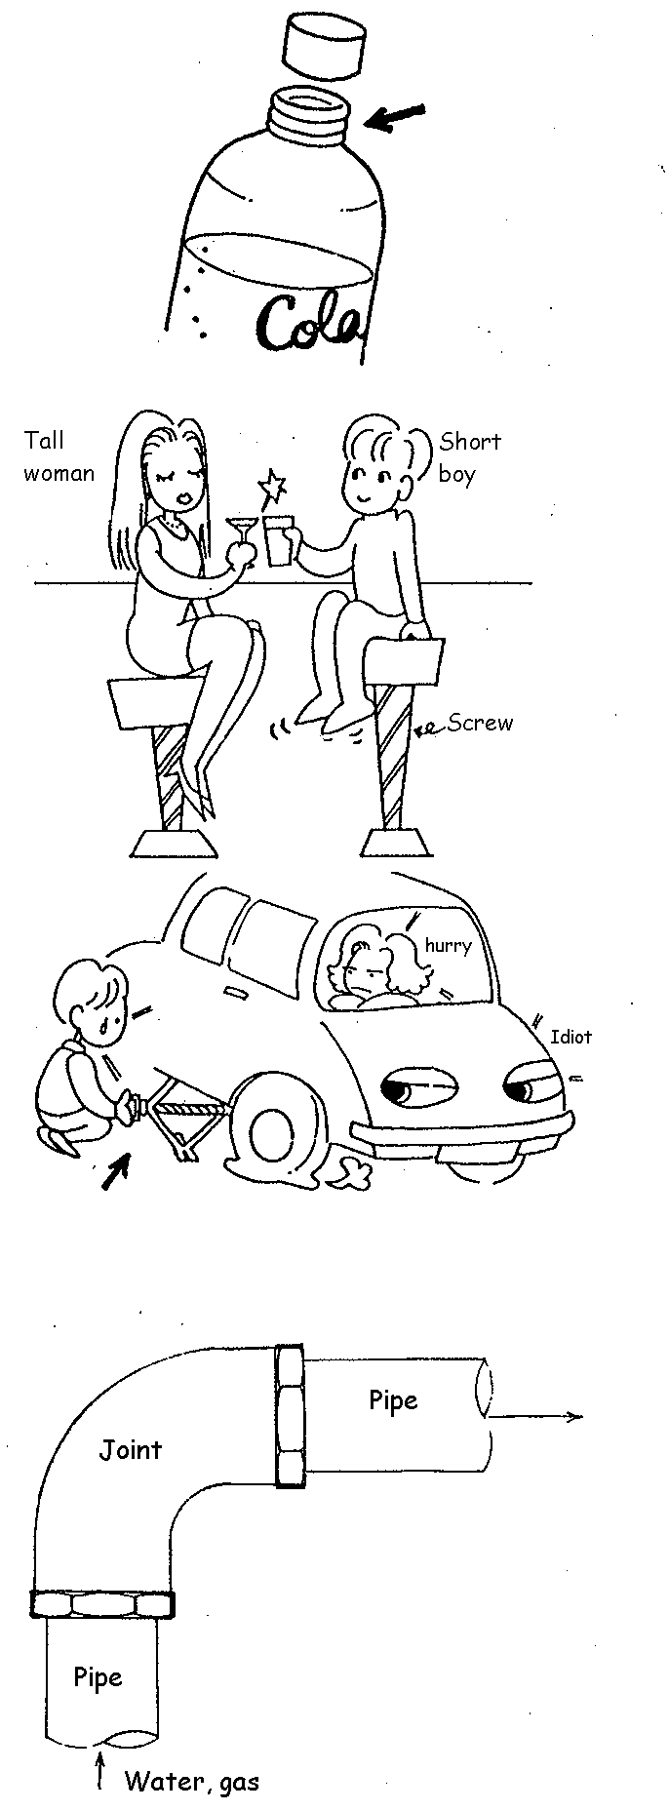
- Stick thread

To make two things tight or loose

- Thread for length adjustment

To adjust the length or height

- Motional or power transmission thread

To move things by rotation or transmit a power

- Connecting thread

There are some joints in water pipe or gas pipe to turn the direction. A connecting thread is used for joint of pipes.

3. Types of thread

- RH thread and LH thread

RH thread: go forward with clockwise revolution
LH thread: go forward with
Counterclockwise revolution

***Most of the threads are RH thread***

- The umber of thread

Single-start thread: Lead is equal to pitch

Multi-start thread: The umber of start thread is more than two times

***Most of the threads are Single-start thread***

- Types of thread

There is a wide range of thread according to the countries, purposes.

(1) Screw thread
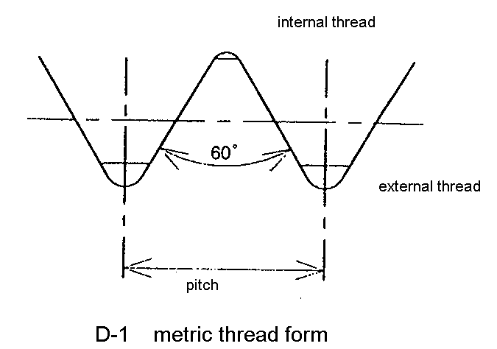
- Metric screw thread (M)

is the most common type of general-purpose screw thread, used in many countries such as Japan, Germany, and France etc
  - Mainly in fastening.

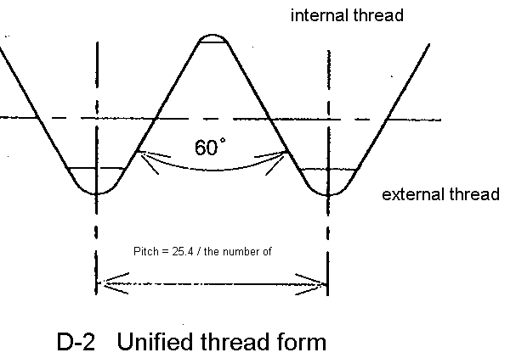

2) Unified thread (UNC, UNF etc)

The pitch is represented by the number of threads per inch.
  - Commonly used in the U.S.
Pitch = 25.4 / # of threads

3) Whitworth thread ( W )

Has the 55°thread angle and the pitch is represented by the number of threads per inch.
  - Sometimes used in building
components

(2) Pipe thread

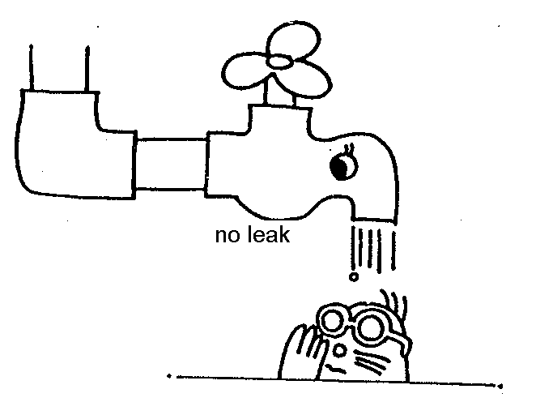
It is mainly used for connecting pipes. There are some kinds of pipe thread such as pressure-tight joints to seal gas and liquid, or mechanical joints.
There are two major threads, ‘’National pipe thread(NPT)’’ for the U.S and ‘’British standard pipe thread’’ for the U.K. Each standard has both ‘’Tapered thread’’ and ‘’Parallel threads’’.

- British standard pipe thread (BSP)
The thread angle is 55°.There are “Rc”,”R”,”Rp” and ”G(PT,PS,PF)”
in JIS standard, which are commonly used in the world.
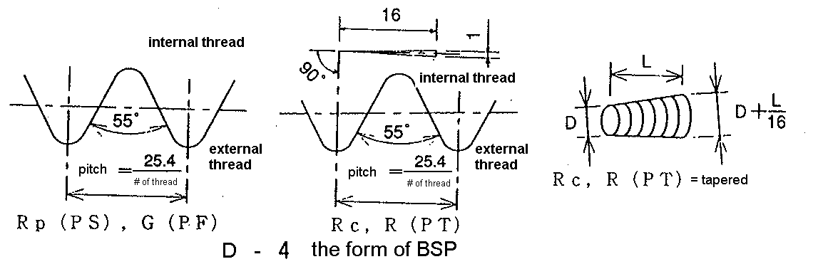

- National pipe thread (NPT)
The thread angle is 60°.
The standard ones are “NPT”, “NPTF”, “NPSC” and “NPSF”. Although these are not included in JIS or ISO standard, many applications are using these threads.
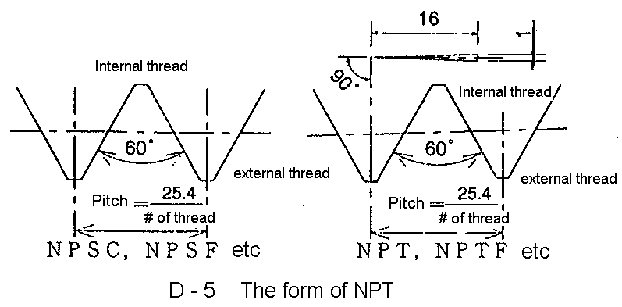

3) Symbol and application for pipe thread

T-1 Symbol and application for pipe thread
Name |  | Symbol | Application
BSP | Taper pipe threads | R,Rc(PT) | Pressure-tight joints
BSP | Parallel pipe internal threads | Rp(PS) | Pressure-tight joints
BSP | Parallel pipe (external) threads | G(PF) | Mechanical joints
NPT | Taper pipe threads | NPT | Mechanical joints
NPT | Parallel pipe internal threads | NPSC | Mechanical joints
NPT | Taper pipe thread for pressure-tight joint | NPFT | Pressure-tight joints
NPT | Parallel fuel pipe internal thread for pressure-tight joint | NPSF | Pressure-tight joints

4) Connection of pipe threads
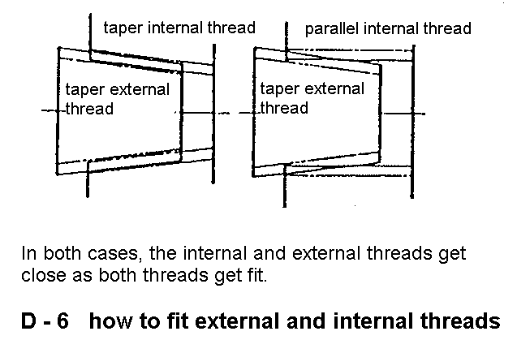
For pressure-tight joints in BSP, R, PT (external thread) connect with Rc, PT, Rp, PS (internal thread). In NPT, NPTF (external thread) connect with NPTF, NPSF (internal thread).
As for BSP, G and PF are used for both external and internal thread. In NPT, NPT is used for external thread, NPT and NPSC is used for internal thread.

The mistake causes a big accident such as gas leak or oil leak, thus, please be careful to use it correctly.

(3) Others

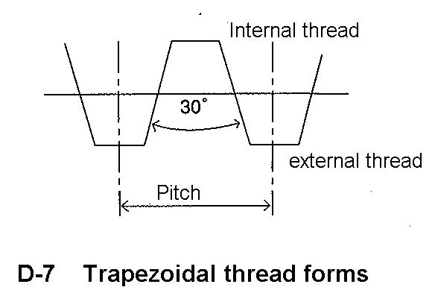
- Trapezoidal thread forms

Trapezoidal thread forms are screw thread profiles with trapezoidal outlines. They are the most common forms used for lead screws for machineries and measuring equipments. The thread angle is 29 ~ 30 degree.

2) Square thread form
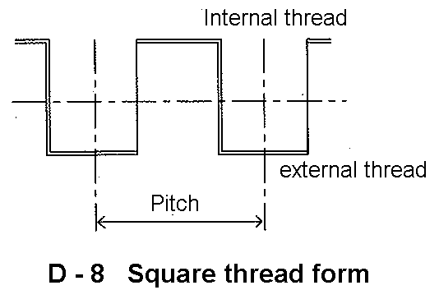
The square thread form is a common thread form for lead-screws. It gets its name from the square cross-section of the thread. The greatest advantage of square threads is that they have a much higher intrinsic efficiency than acme threads. Due to the lack of a thread angle there is no radial pressure, or bursting pressure, on the nut. This also increases the nut life.

As for the others, there are still a wide range of threads in the world such as
  - Thread with round form which is often used in light bulb,
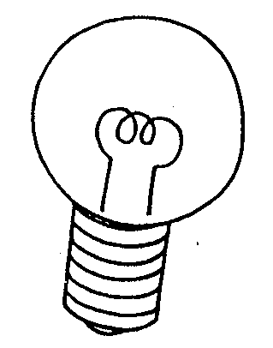
  - Ball screw for a mechanical linear actuator that translates rotational motion to linear motion with little friction.


4. Description of threads

There are many ways to express the types of thread as many as threads exist. Most of them describe their diameter, pitch and the class of limit. The most common ones, metric threads and unified threads are mentioned as follows.

- Metric threads

Type Major Diameter x pitch class

M millimeter 4H, 5H, 6H, 7H,
4h, 6h, 6g, 8g

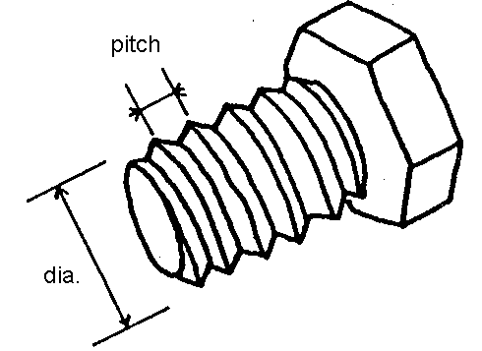

Ex) M10 x 1.5 6H

- Unified threads

Major diameter x Number of ridges per inch Type class

Inch or No. UNC, UNF etc 1A, 1B
2A, 2B etc

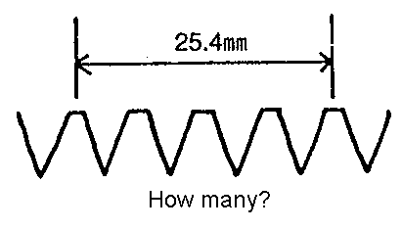
Ex) 1 / 2 – 20UNF 2A
No.5 – 40UNC 2B

< For # thread>
- Major diameter = 0.060” + 0.013 x # inch

- Pipe thread

Type Major diameter - Number of threads per inch class

PT, PS, PF etc diameter of pipe A, B etc

Ex) PT ¼ - 19

The description sometimes includes a number of lead and direction of rotation.
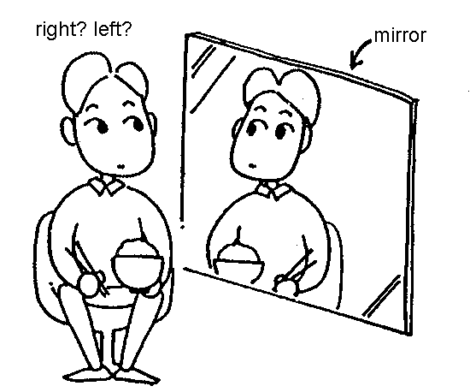
Ex) LH double-start M6 x 1 6H

5. The name of thread’s detail

Typical parts of thread are as follows
(Ref: JIS B 0101)

(1) Basic profile of screw thread

- A cross section of thread

(2) Major diameter of external thread

- Diameter of a virtual cylinder which touches the crest of the external thread

(3) Pitch diameter

- On a straight thread, the diameter of an imaginary cylinder where the width of the thread and the width of the space threads are equal.

(4) Minor diameter of external thread

- Diameter of a virtual cylinder which touches the root of the external thread

(5) Minor diameter of internal thread

- Diameter of a virtual cylinder which touches the crest of the internal thread

(6) Major diameter of internal thread

- Diameter of a virtual cylinder which touches the root of the internal thread

(7) Thread angle

- Angle between adjacent flanks measured at the cross section of screw thread – including the axis of the screw thread

(8) Pitch

- The distance from a point on one thread to a corresponding point on the next thread measured parallel to the axis

(9) Lead

- The distance a screw thread advances axially in one complete turn

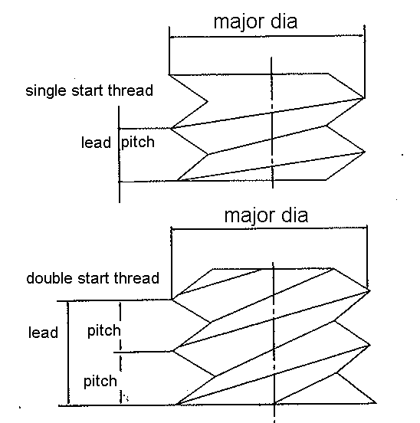

The relationship between pitch and lead

- Single start thread:
Lead = Pitch

- Double start thread:
Lead = 2 x Pitch

- Multiple start thread:
Lead = The number of start threads x pitch

Ⅱ. Gauge

- Usage of Gauge


When external thread is going into internal thread, we can feel small resistance or big resistance. This is relating to diameter of both threads.
More clearance between threads makes loose joint, and less clearance makes tight joint.
Most of the threads are standardized to make it right fit. Gauge is often used to investigate the thread engagement.

- Limit of thread
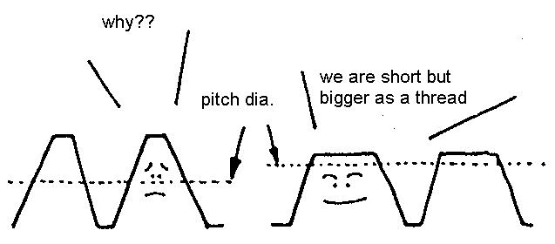
Limit of thread is based on pitch diameter. When threads are tightened, each slopes are contacted each other although crest and root are not touched. Pitch diameter represents the distance between slopes.

- Types of gauge

There are three types of gauge in general.

  - Limit gauges for screw threads
  - Standard screw thread gauges
  - Gauges for pipe thread

T-2 description of Gauge

Limit gauges for screw threads | 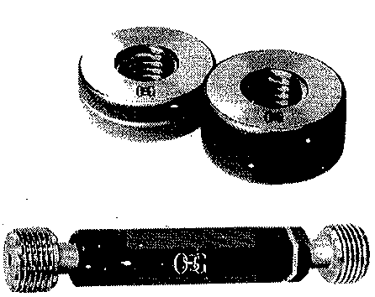 | The GO and NOT GO ends of the gauge form one set, and the thread standard and class are prescribed. For the NOT GO side, there is a JIS method for manufacturing and inspection, but no ISO classification.
Standard screw thread gauges | 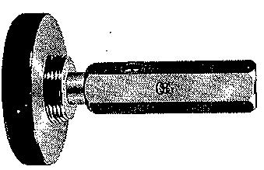 | This is a standard measurement gauge that also has correct thread standard angle. One set includes a thread-plug and thread ring gauge. These gauges should never be forced, nor should they fit too loosely.
Gauges for pipe threads | 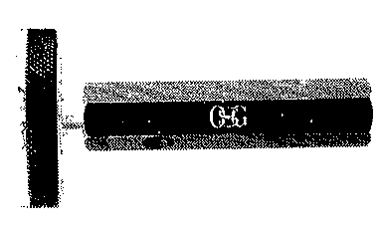 | Parallel pipe thread gauges are the same as screw thread limit gauges; the GO and NOT GO side form one set. Taper pipe thread gauges, however, have special notches. Both taper pipe plug gauges and taper thread ring gauges are available.

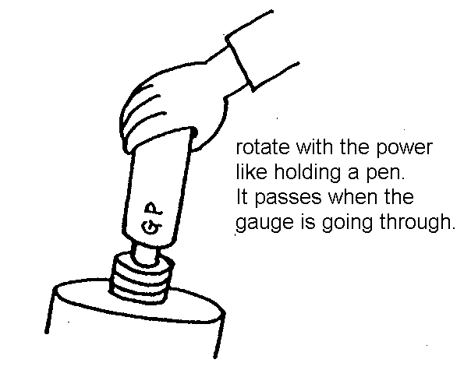

- Description of Gauge

Description of Gauge consists of “standards”, “RH or LH (RH can be omitted)”,
“Thread size” and “symbol of the gauge”.

(Ex) JIS B 0252 M10 x 1.25 6g GR
① ② ③ ④

Limit gauges for fine screw threads M10 x 1.25 for 6g GO screw ring gauge
① ② ③ ④

① Standard
② Size, LH or multiple-thread
③ Class
④ Type

Please refer to OSG Catalogue to look for symbol of the gauges

Ⅲ. Basic of Tap

There are an external thread and an internal thread in threads. There are many ways to make external thread in general; in contrast, internal thread is made by either Tap or Lathe. Tap is often used in most cases such as mass production or small dia operation.

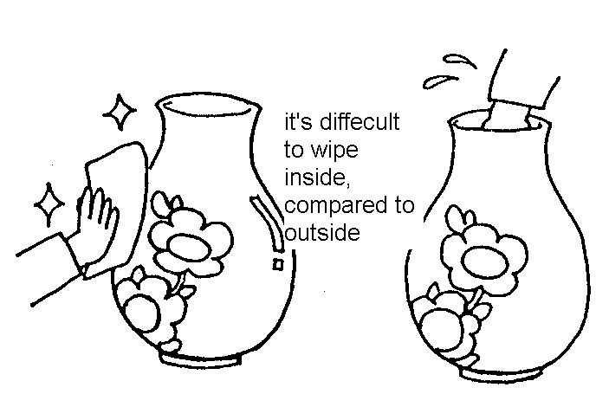
1. What is tap?

Tap is a tool to make an internal thread in holes with similar shape of external thread.
Making internal thread with this tool is called Tapping.

2. Feature of Tap

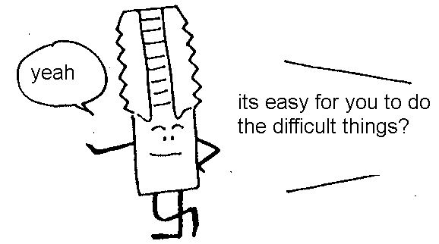
- Economical
- Whoever can do it
- Easy
- Can use for both machine-tapping and
hand-tapping

3. Terminology

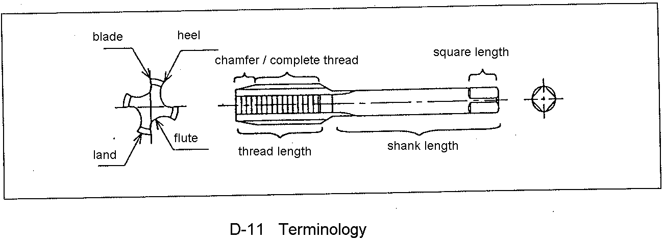

4. Tapping Mechanism

How each part of Tap is working in an operation is explained here.

(1) Chamfer
Tapping is carried out only by the chamfered portion of the tap. Chamfer determines tool life, cutting quality etc, and the length of chamfer is changeable.

- Detail of tapping

Here is the explanation of operation for the tap with 4 flutes and 2P chamfer.

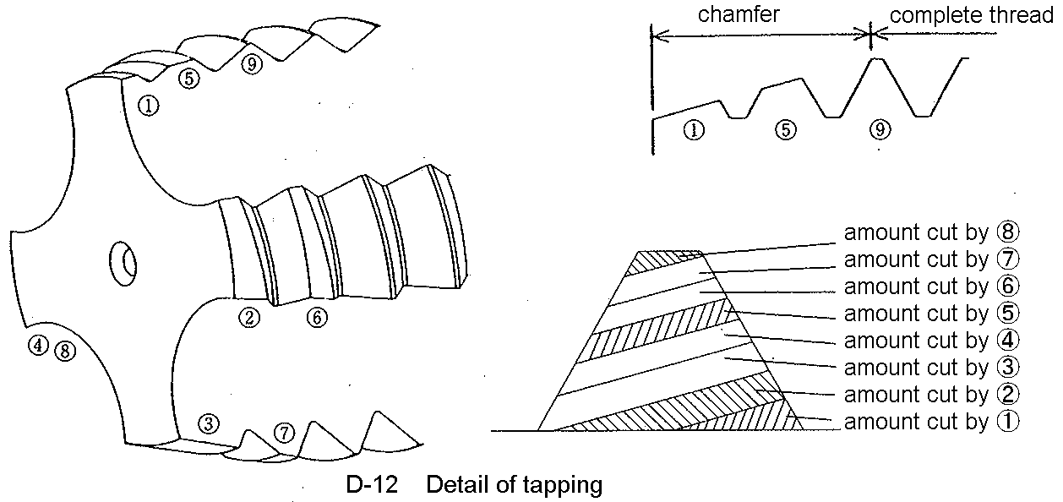

①~⑧ are called chamfer, and the others(⑨~) are complete thread. The chamfer makes the internal thread and complete thread is only for guiding, which means cutting is actually done by chamfer part only.



2) The length of chamfer and its affection

Table below is about the relation of chamfer length and affection to internal thread.

T-3 The length of chamfer and its affection
The length of chamfer | Over size amount | Surface | Tool life
Long | Small | Better | Better
Short | Big | Worse | Worse

Although longer chamfer makes better quality, it makes the time of operation longer and requires more space in the bottom of hole.

3) Complete thread

Complete thread is not cutting the material itself, but guiding the Tap. Weak guidance causes less precision.
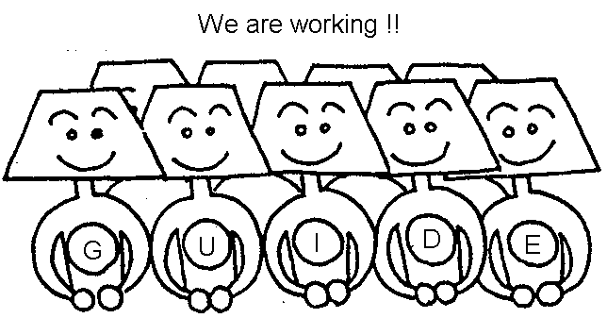

Weak guidance makes the cutting like D-13, and the pitch diameter becomes over-sized.
This shows over-sized internal thread.

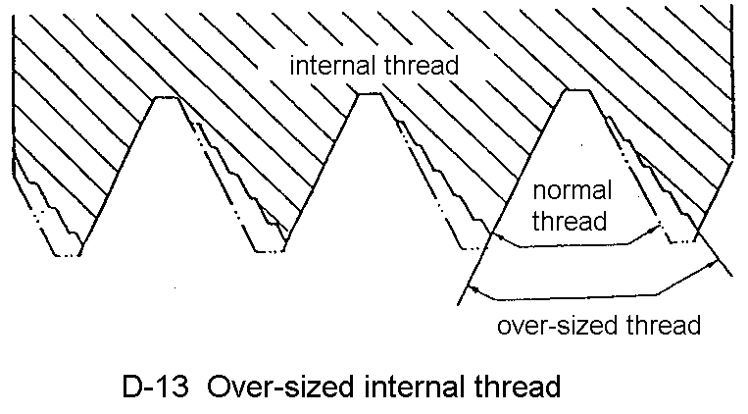

(2) Flute

Flute mainly has four roles as follows:

- Remove chips

- Space for chips

- Let oil in the hole

- Shape the blades

Cutting taps for internal thread make chips in operation. Flute has an important role for chip removal. The chips made by chamfer are going out though flute. Oil is going into the bottom of hole through flute.

(3) Rake angle

A tap has rake angle as well as the other cutting tools. Each material has suitable rake angle in operation. For example, T-4 shows suitable rake angle for Hand Tap with straight flute. Generally, large rake angle is used for soft material and small rake angle is used for hard material.

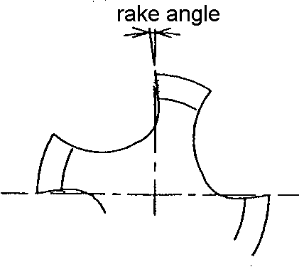

(4) Shank

A shank is a part of Tap to be held by the holders such as three-jaw chuck and collet etc. circularity and concentricity against thread part affect run-out of spindle.

- Shank square

Tap operation requires more torque, compared to drilling.
However, a holder can grab the shank square tight, which prevent to slip the holder and shank.

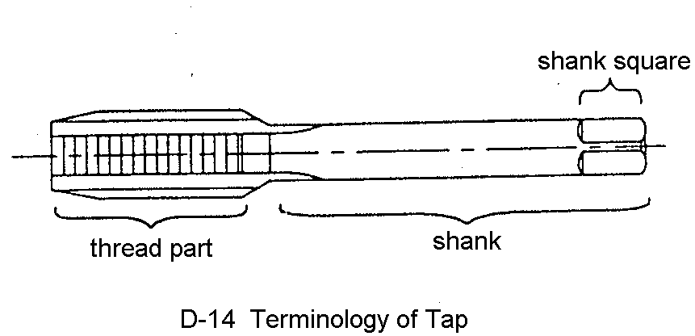

(6) Center

It is necessary for tap production although it is no use for tapping operation itself. This is used as a standard in any Tap production line to make a high-precision tap.
In OSG, basically Tap with below M6 has a male center and Tap with over M6 has a female center.

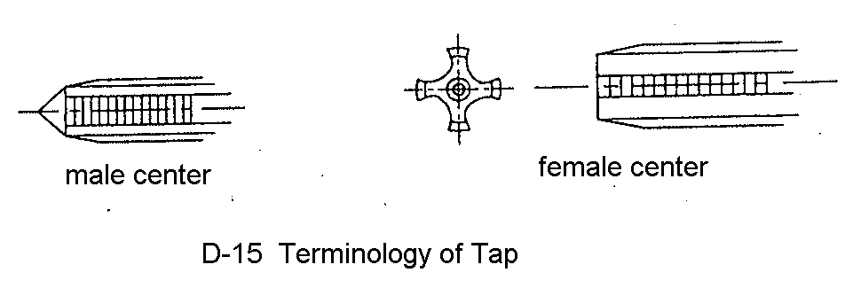

Ⅳ. Material / Limit / Surface treatment

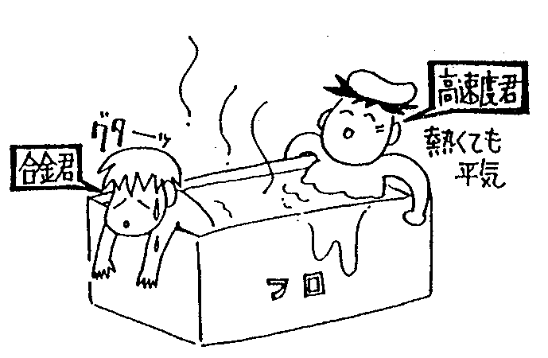
- The material of tap

The material of tap is getting high-grade like from SKS to SKH to even Carbide recently. The difference between SKS and SKH is hardness in a high temperature. During the tap operation, the blade of tap is heated by friction, but SKH material can keep its hardness in high temperature which reduce damage in blade.

(1) High Speed Steel (HSS)

There is a various of HSS materials. The material for Tap has been changing as the technology of tap production advance.
Below “T-5” shows the history of changing the material. SKH58 was commonly used for Tap before. Currently SKH53, containing 3% of Vanadium, is the most common material for Tap.
SKH56, containing 8% of cobalt, is also used for high temperature application.

(2) Powder Metallurgy HSS (CPM, XPM)

Containing more Vanadium makes more hardness under high temperature and wear proof. Powder Metallurgy HSS, one of the High Speed Steel, is easy to grind even though Vanadium contains a lot due to a special manufacturing process.
OSG’s powder metallurgy HSS contains 5% of Vanadium. It means more wear proof and defect resistance because of microstructure like in “D-16”.

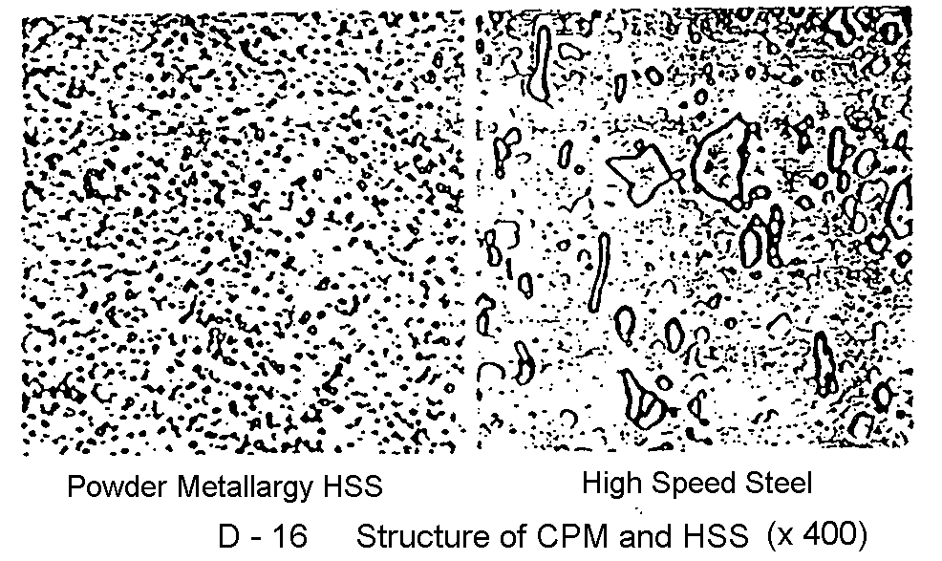

(3) Carbide

Carbide is expected to increase their consumption in the future. It is the hardest material in Taps, and its tool life could be ten times longer than that of HSS in some applications.
However, it has less defect resistance than HSS, therefore commonly used against FC, ADC, and Thermo Setting Plastic for mass production.

(4) Alloy Steel Tool (SKS)

It is cheaper than HSS, however, wear resistance is low. Their consumption is getting less and less, because of the demand in both efficiency and speed for operation.
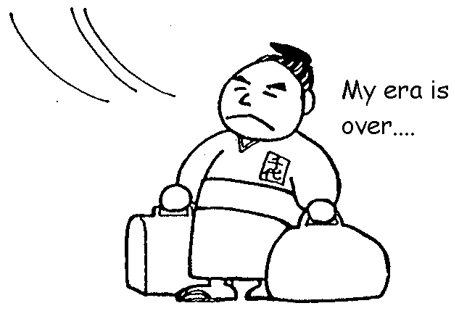

2. Limit of Tap

(1) Limit of Internal thread

“T-6” shows the limit of JIS, ISO, and ANSI. “D-17” shows the graph of each limit.
Limits are calculated for major dia, pitch dia, minor dia, and pitch tolerance etc.
In Japan, “JIS class 2” is commonly used in general thread.

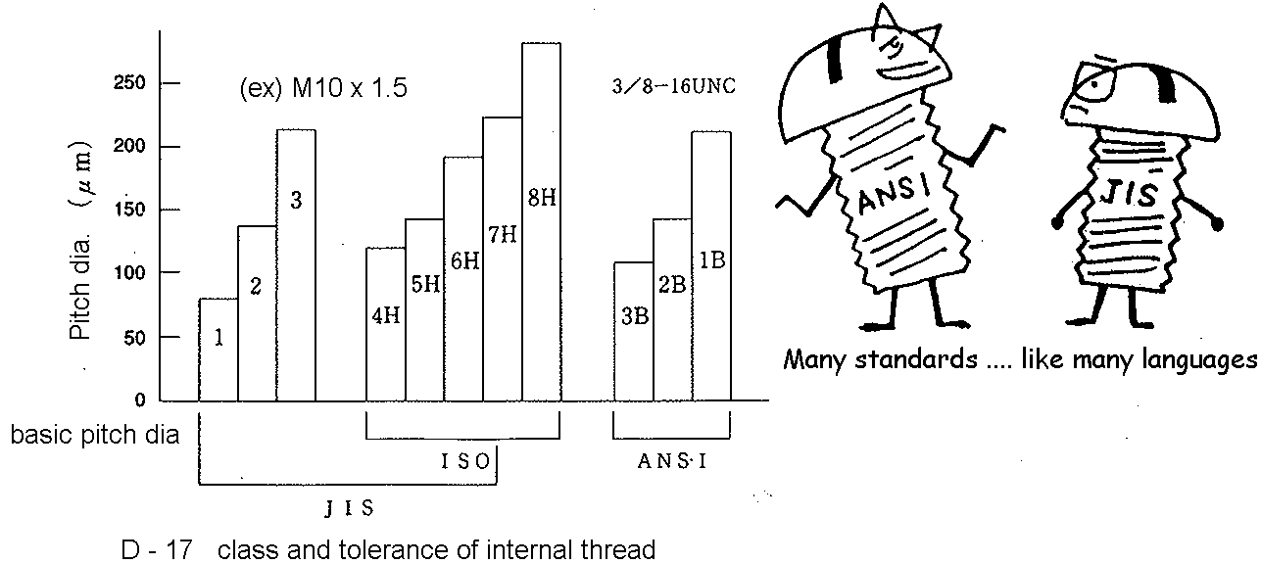

(2) Limit of Tap

Tap’s limit is calculated by major dia, pitch dia, minor dia, pitch, run-out of spindle etc in JIS standard. “T-7” shows the class of Tap in JIS.

1) The limit of pitch dia in Tap

Generally, Tap’s limit is based on internal thread’s limit, however internal thread does not always have same limit as Tap’s class. Pitch dia of internal thread is usually a bit larger than Tap. This gap is called oversize amount. Oversize amount depends on work materials, thread shapes, and cutting condition, therefore it is not easy to choose proper size (limit) in Tap.
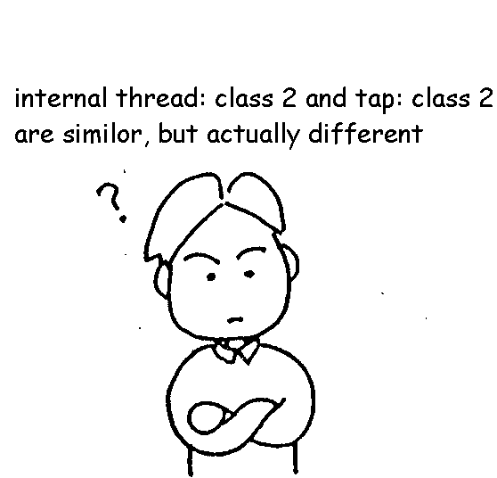

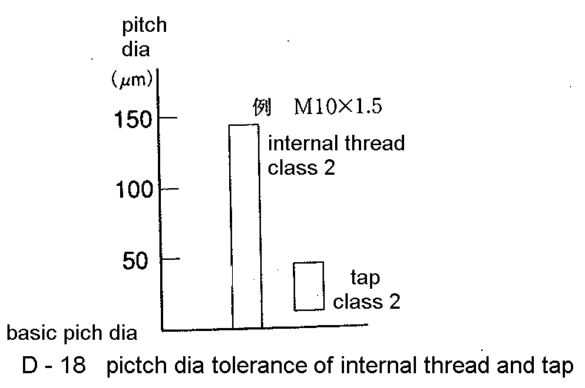

The standard limit for Tap is normally “class 2” or “class 3” in JIS, but this is not enough to choose. Therefore OSG applies a unique system of tap pitch diameter limit to select the best tap pitch dia for your work conditions. There are three types of OSG limit, “OH limit”, “OT limit”, “RH limit”, using the step method. “OH limit” and “OT limit” are for cutting tap such as hand tap, and “RH limit” is for forming taps. “OH limit” and “ “OT limit” are depending on the pitch.

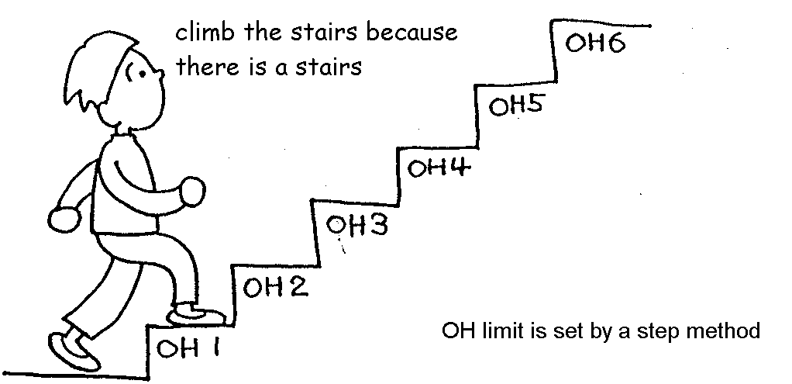

(Unit: mm) (n= OH number) (Unit: mm) (n= OH number)

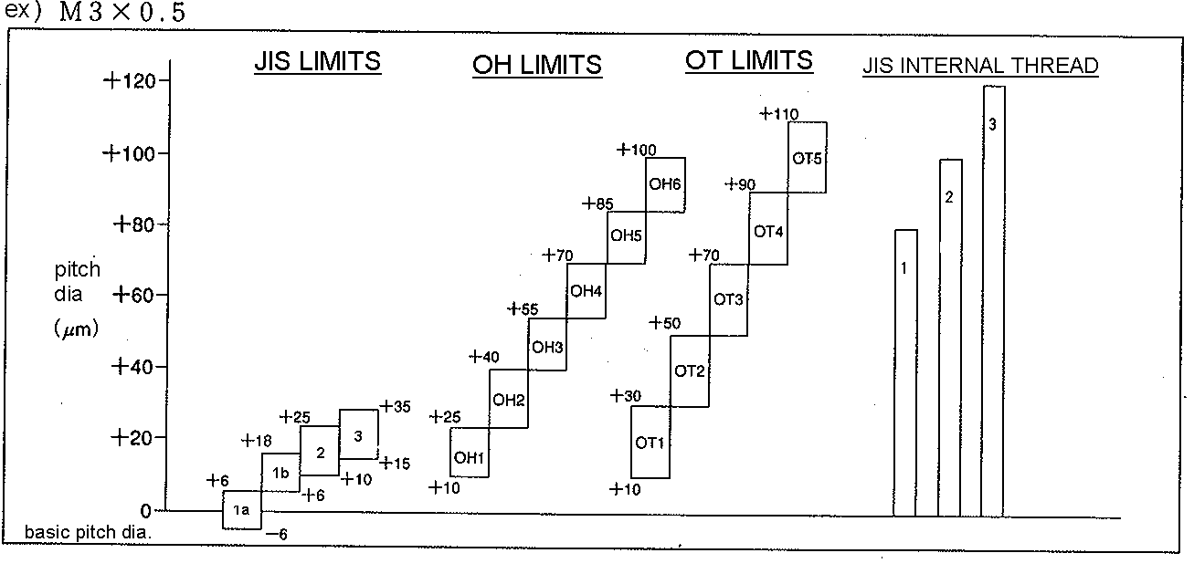

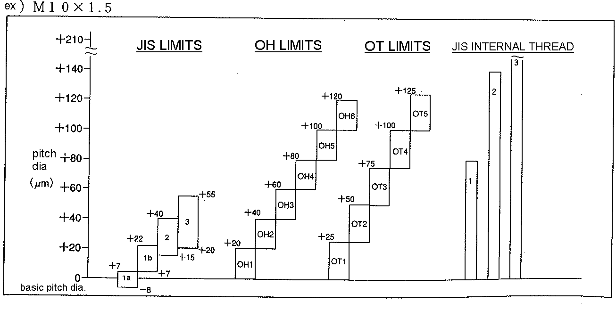

RH Limit
OSG’s forming taps (NRT, HRT) are described by the RH Limit system. The limits are established in increments of 12.7μm.

Upper limit: 0.0127 x n
Lower limit: 0.0127 x n – 0.0127
( n = RH number)
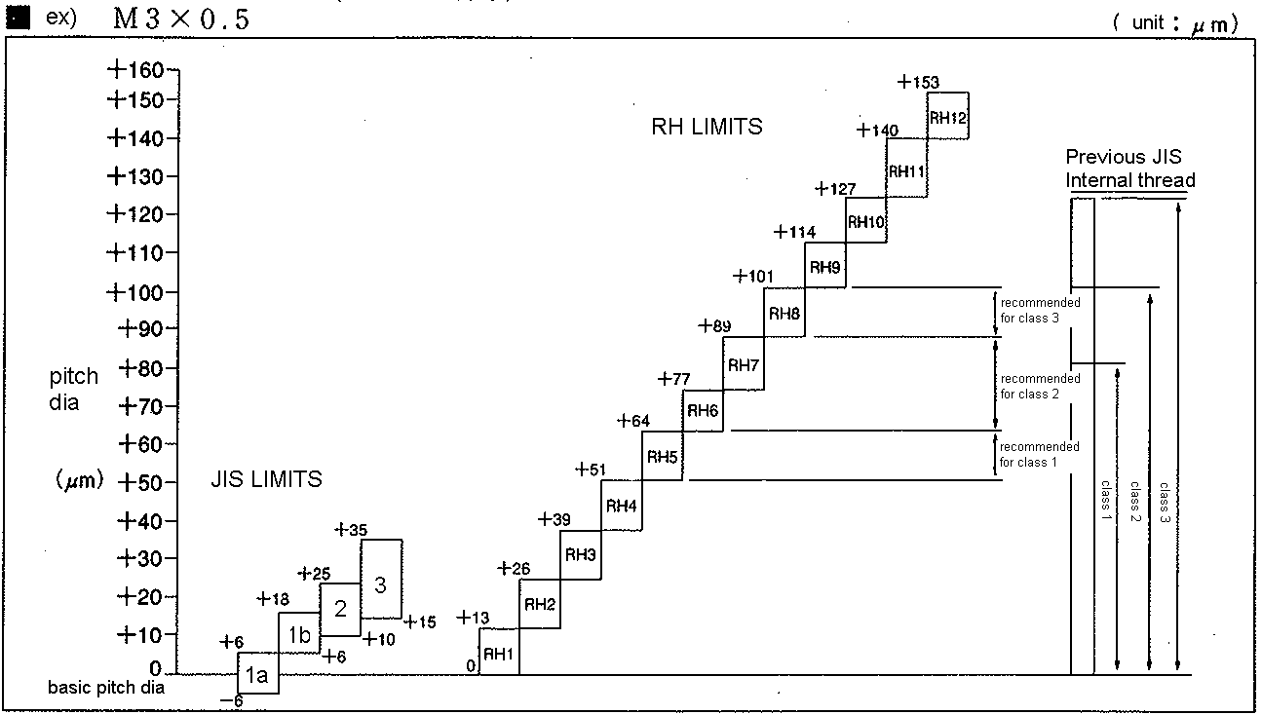

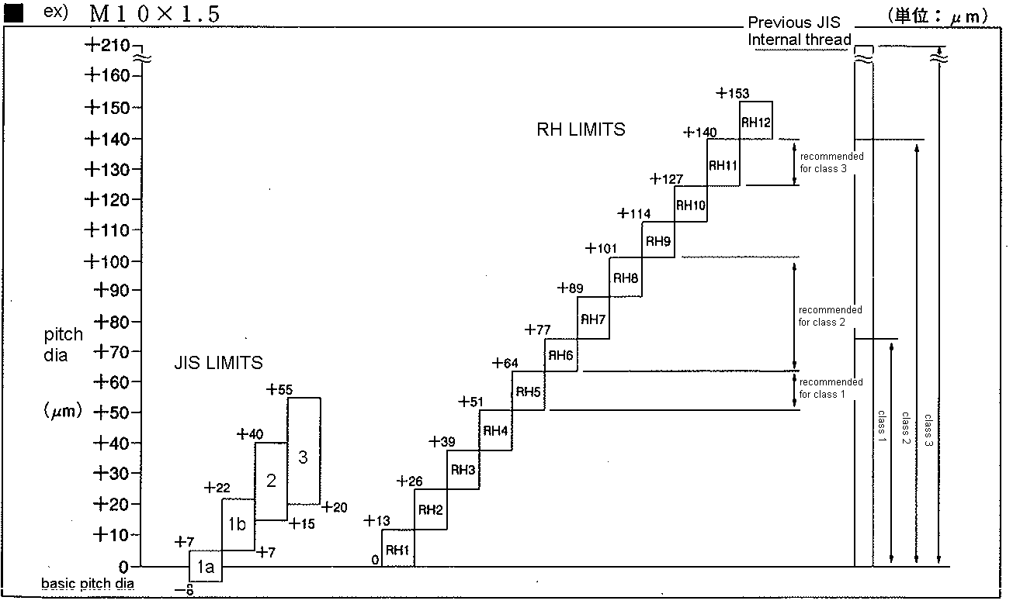

2) Tap run-out

Tap run-out often causes over-size of internal thread because tap receives unnatural force and chamfer damages during operation. (D – 19)
JIS has a regulation of “T – 8” which shows the tolerance of thread and shank run-out.

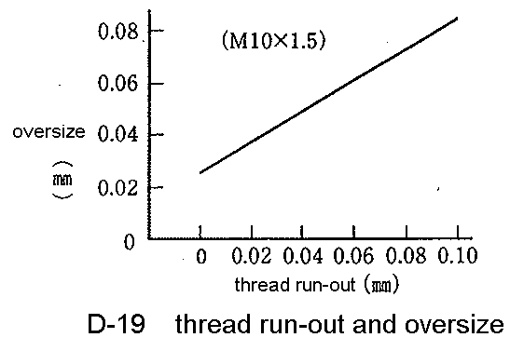
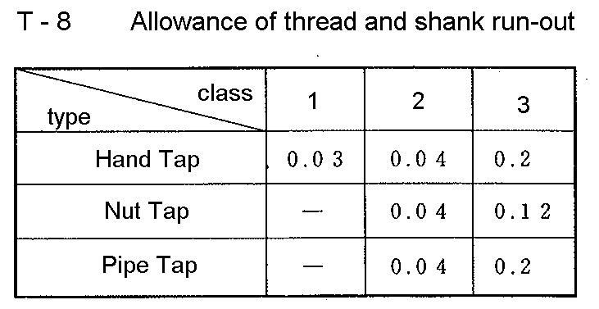

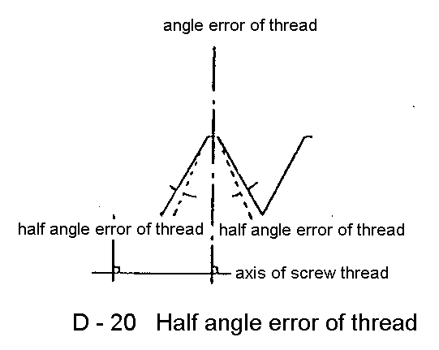
3) Error of half angle

Flank angle error at point where thread profile is symmetrical to the center line of the thread ridge.

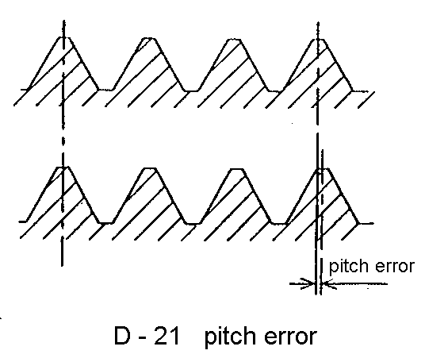
4) Pitch error

It is about the difference between the actual pitch and the prescribed pitch. Pitch that is larger than the prescribed pitch is “plus”, while pitch that is smaller than the prescribed pitch is “ minus”.

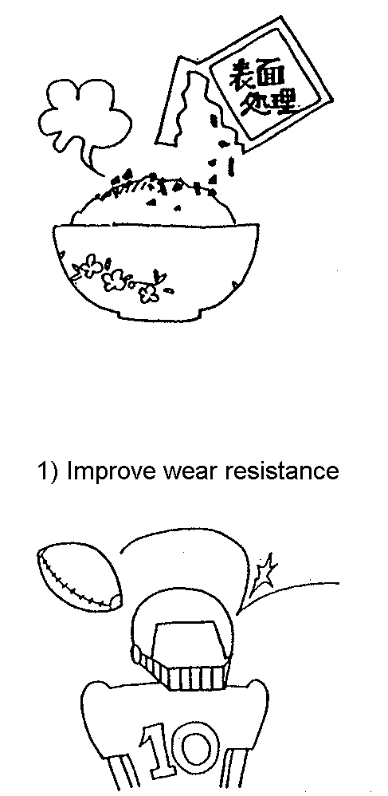
3. Surface treatment of Tap

Surface treatment can increases performance in tapping.
The main purpose on surface treatment is as follows.

- Improve wear resistance

- Prevents taps from welding to the tapped material

- Lower the coefficient of friction

To improve these points, various surface treatments are developed. Here is the explanation of “steam oxide”, “nitride”, and “TiN coating” which are often used on HSS Tap.

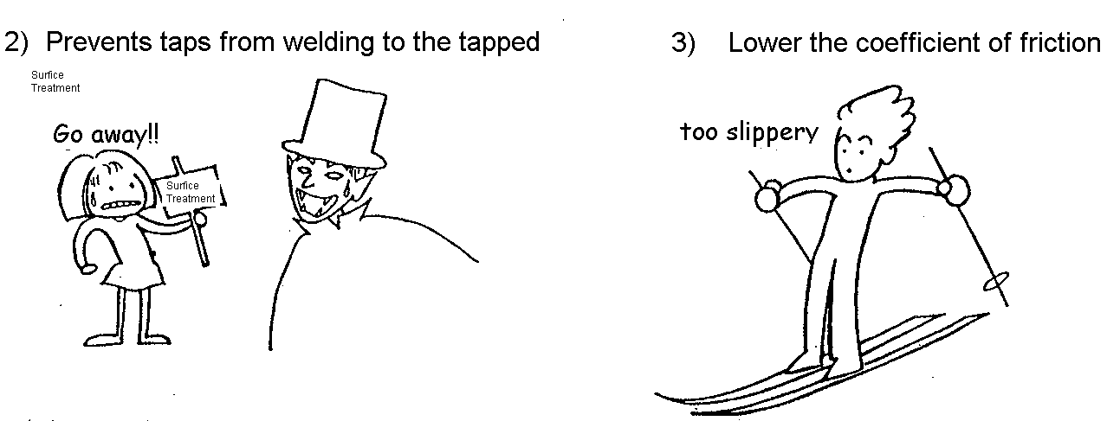

(1) Steam Oxide

Steam Oxide is produced in a controlled dry steam furnace at an elevated temperature. The steam treatment of ferrous metals forms a thin, hard, well-adhered, blue-black oxide film, called magnetite (Fe3O4). The process is often referred to as ‘'blackening'.

1) Characteristic

①This coating in effect acts like a sponge, basically allowing the cutting oil to sit atop of
this porous surface.

②Prevent fusing and welding between tap and work material

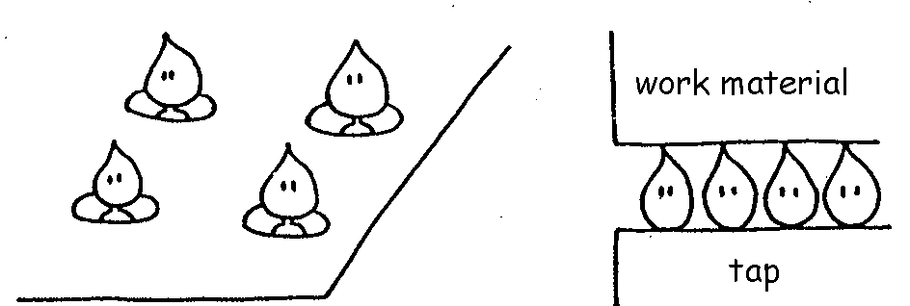

2) Application

It will prevent fusing to the work material due to the added lubricity for example “Stainless Steels”, “Cast Steels”, ”Nickel Alloys”, “Chrome Steels”, and is not recommended for non-ferrous materials such as “Aluminum Rolled”, “Die Casting”, “Brass” etc.

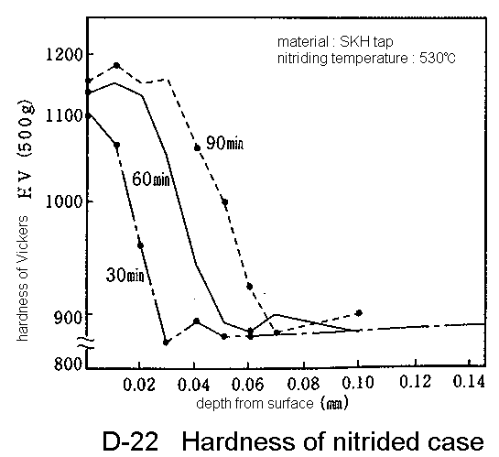
(2) Nitride

Nitride is a process used to increase the hardness and wear resistance of the surface of the tap. The nitride process will infiltrate into the base material causing this increased performance. This coating is silver in color, typically found with a thickness of 30-50μm, and with a surface hardness of 1,000-1,300 Vickers.

1) Characteristic

① Wear resistance + hardness on surface

② Improve heat resistance

2) Application

This coating is used particularly in abrasive materials such as “Thermo Setting Plastic”, “Cast Iron”, “Die Casting”, “Aluminium Alloy Casting”. These materials are often cut by Hand Tap because the chips break into small pieces. It is also good for NRT when wear resistance is required.

(3) TiN coating

Titanium Nitride is an all purpose application coating. It is always found as gold in colour, with a thickness ranging from 1-3μm. It typically has a surface hardness of 2,000 Vickers, a coefficient of friction of 0.04 and a oxidation temperature of 500°C.

1) Characteristic

① Wear resistance + hardness on surface

② Lower Coefficient of Friction

③ Prevent fusing and welding between tap and work material

2) Application

It can be used in a variety of materials from mild steels to hardened steels. For example, “Stainless Steels”, “Carbon steels for machine structural use”, “Alloy steel for structure”, “Heat treated steels” etc.

TiN coating is also good for the application with water soluble which cause more trouble of welding than non-water soluble to prevent welding etc.

(4) TiCN coating

Titanium Carbon Nitride is a higher performance coating than TiN, but like TiN it is also considered an all purpose coating. It is bluish/silver in color, with a thickness of 3-5μm. It has a surface hardness of 3,000 Vickers, with a coefficient of friction of 0.03 and an oxidation temperature of 400°C.

1) Characteristic (compared to TiN coating)

① Wear resistance is 1.5 times higher

② Lower Coefficient of Friction is 30% lower → better lubricity

③ less welding and built-up edge

2) Application

① Enable high speed cutting like about twice as fast as that with non-coating, and also
reduce welding.

② Longer tool life can be expected like 3 times as long as that of HSS, 1.5 times than
that of TiN coating.

(5) Summary of surface treatment

T – 9 Type and characteristics of each surface treatment
Type | Characteristics | Purpose | Oversize | Application
Steam Oxide | - Thickness: 1 – 3μm  - Oxidized coat layer (Fe3O4)  - Porous surface for cutting oil to be held in pores  - Less coefficient of friction  - Prevent fusing  - Not good for non-ferrous materials | Prevent fusing | Less oversize | Material easily fused tap  - Stainless  - Titanium alloy  - Mild steel  (SS400,S15C etc)
Nitride | - Thickness: 30 – 50μm  - Surface Hardness: 1,100 – 1,300 HV  - Improve wear resistance  - Infiltration into basic material | Improve wear resistance | Less oversize | Abrasive materials  - Cast Iron  - Silicon alloy  - Plastics
TiN coating | - Thickness: 1 – 3μm  - Surface hardness: 2,000HV  - Improve wear resistance  - Less coefficient of friction  - Prevent welding | Prevent fusing  Improve wear resistance | + 10μm | Difficult to machine material  - Hardened steels  - Stainless steels  - Heat treated steels  - Titanium alloy
TiCN coating | - Thickness: 3 – 6μm  - Surface hardness: 2,700HV  - Improve wear resistance  - Less coefficient of friction  - Prevent welding | Prevent fusing  Improve wear resistance | + 10μm | Difficult to machine material with high speed cutting  - Alloy steels  - Prehardened steels  - Titanium alloy  - Stainless steels

Ⅴ. Types of Taps

There are many kinds of taps for every application. Here is the explanation of standard tap, special tap, a wide variety of taps, flutes, materials, etc below.

1. Standard taps, special taps, and taps per applications

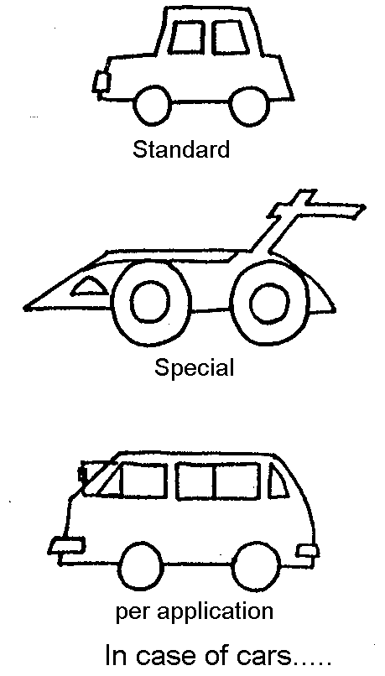
There are basically two kinds of taps, standard taps (having stock), and special taps (made after order). Standard taps can be taken anytime, and any quantities, however sometimes have a problem as there are a wide range of work materials and operations.
In this case, special taps are supposed to be chosen to handle the each condition even though the price and delivery time are more than standard ones. To take both merits, OSG also has taps per applications in stock.

2. Flute of the taps

The flute design will classify what “family” of taps a particular tap will fall into. There are four types of flute design which are in Hand taps (straight), Spiral fluted taps (spiral flute), Spiral pointed taps (spiral point), Forming taps (flute-less) in D-23.

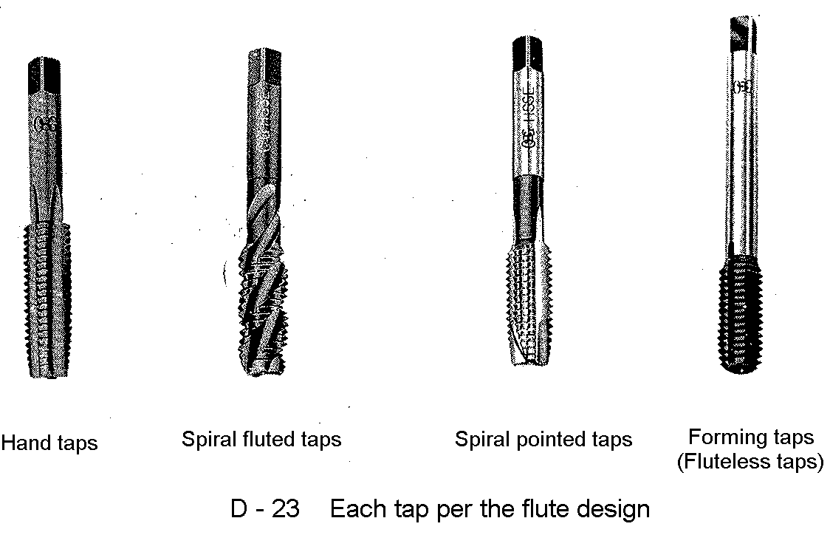

Hand taps, Spiral fluted taps, Spiral pointed taps are cutting taps which make an operation by cutting internal thread. In contrast, Forming taps make internal thread by forming a drill hole.
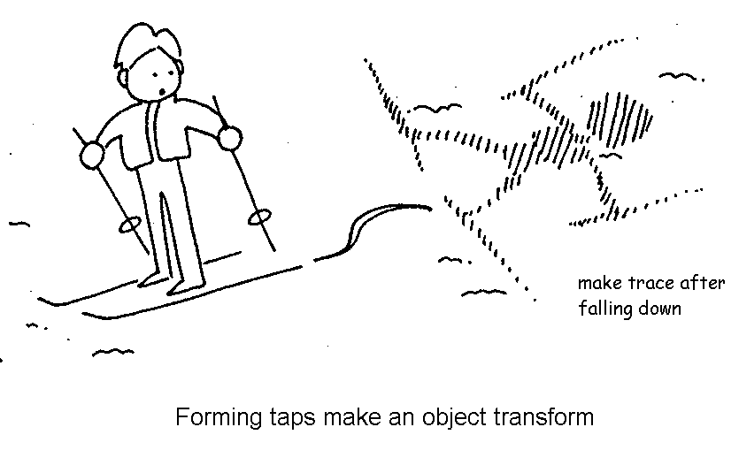
For example, if we put external thread into clay by rotation and pull it out by opposite rotation, internal threads are made in the clay. This is the same operation done by forming tap and work material instead of clay and external thread. Therefore, Forming taps never make chips in contract with cutting taps. D – 24 shows how Forming tap makes internal thread.

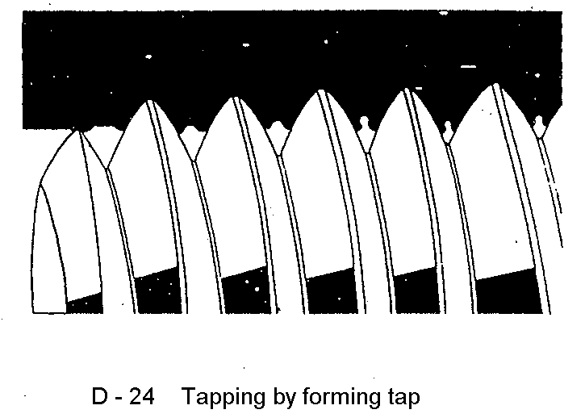
Each tap has different kinds of chip control. In other words, chip control depends on the application. For example, Spiral pointed taps which push chips forward are for thorough hole in contrast with Spiral fluted taps which evacuate chips out of hole. D –25 shows how Spiral pointed taps and Spiral fluted taps remove chips.

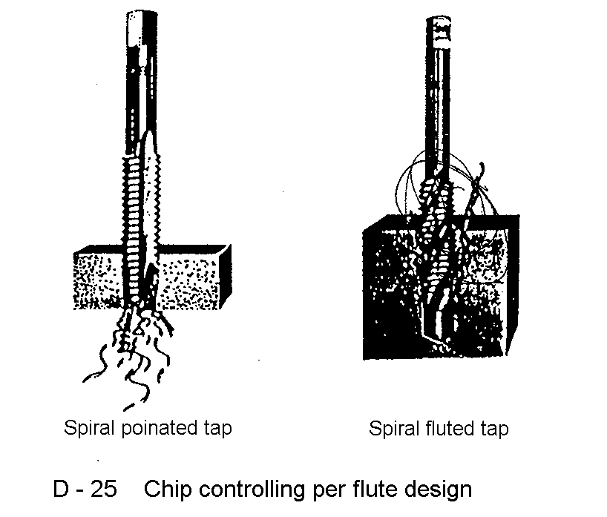

Spiral fluted taps can be used for both through hole and blind hole. However, it is important to choose appropriate tap because each tap has advantages and disadvantages.
Forming taps are used in particular applications with accurate drill hole and soft materials containing less carbon, or aluminium because of the chip-less operation. T – 10 shows the characteristics and applications for each tap.

T – 10: The characteristics and applications for each tap

Types | Characteristics | Application
Hand taps  (HT) | - Straight flute  - Strong cutting edges  - Easy to re-grind | - Hard materials  - Materials where chips come out in small pieces  - For both through & blind holes (short thread depth only)
Spiral fluted taps  (SFT) | - Spiral flute  - For blind holes  - Good cutting action  - Easy to enter material | - For blind holes  - Materials where chips come out continuously in coil shape
Spiral pointed taps  (POT) | - Spiral point (Gun-flute)  - Pushes chips forward with low cutting torque  - Shallow and unique flute form provides strong structure | - For through holes  - Materials where chips come out continuously in coil shape  - High speed tapping
Forming taps  (NRT / HRT) | - Flute-less  - Taps do not produce chips  - Consistant thread limit  - Excellent rigidity | - For both through & blind holes  - Materials with Formability

3. Materials

There are three kinds of materials which are often used in taps, “Alloy tool steel”, “High speed tool steel”, and “Carbide”. Their features are shown in T – 11.

T – 11: The features and applications per tap

Type | Symbol | Definition | Feature
Alloy steel  Tap | SKS | Using alloy steel in material | For small amount, hand-tapping
High speed steel  Tap | SKH  HSSE  CPM | Using high speed steel in material | Trend is W→Mo→V, Co
Carbide  Tap | UMA | Using carbide in material, which is a sintered material containing tungsten and carbon. | Superfine cemented carbide with wear resistance and tenacity

4. Other categories

Taps are categorized by their shapes or applications. Typical types are shown in T – 12 below.

T – 12 Types of taps

Types | Symbol | Definition | Design
Regular hand tap | HT | Categorize to “Taper hand tap”, “Plug hand tap”, and “Bottoming hand tap” | 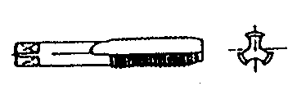
Taper hand tap | HT | A kind of regular hand tap. Chamfer has 9 threads. | 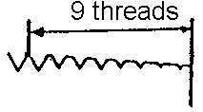

Types | Symbol | Definition | Design
Plug hand tap | HT | Chamfer has 5 threads | 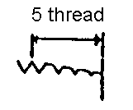
Bottoming hand tap | HT | Chamfer has 1.5 threads | 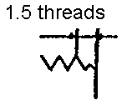
Taper tap | TPT | There is taper part on thread.  Ref: This tap is used to process taper pipe internal threads. | 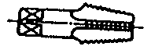
Nut tap | NT | These taps are used for producing nuts. The length of thread and long shank are used to accumulate the nuts, thereby increasing efficiency. | 
Long (shank) tap | LT | Having longer shank, compared to Hand taps | 
Bent shank tap | BNT | Allows tapped nuts to automatically pass through bent shank portion, enabling continuous tapping without reversal or stopping of the machine. | 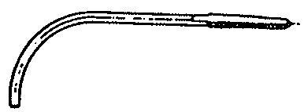
Drill tap | DRT | These taps have a drill point that allows you to make the hole and thread in one operation. Combining these operations greatly improves productivity. | 

Types | Symbol | Definition | Design
Interrupted threads tap | IRT | The tap of which of flutes is taken as an odd number, and the threads of each land have been removed alternately by one thread. | 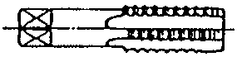
Over-size tap | OST | The generic name of which thread diameters have been made larger than those of the standard size. | ------------
Insert screw thread tap | HL  (HT) | Used for tapping that has a helical coil wire screw thread insert. Compared to ordinary taps of the same nominal size, these taps have the same pitch but have an oversized outer diameter for insert. | -----------



